MACH4METAL

Metalworking machinery
Transito 21,
6909 DA BABBERICH
Netherlands
Tel. +31 (0)316 – 247123
Fax. +31 (0)316 - 247956
info@mach4metal.com
www.mach4metal.com

Account No: 66.52.13.883
IBAN : NL33 INGB 0665 2138 83
BIC : INGBNL2A

ROSA Surface grinder RTRC 1000
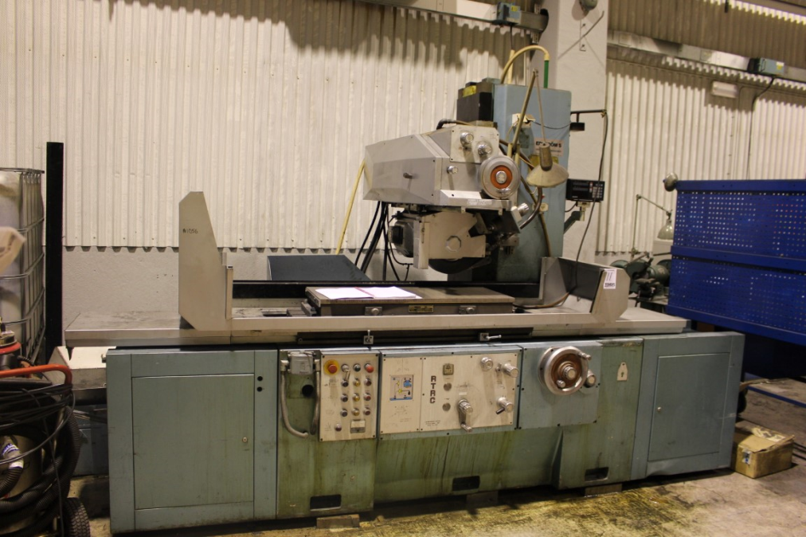

- Make : ARAMANDO ROSA
- Typ : RTRC 1000
- Serial :
- Age :

- Table length : 1.000
- Table width : 400

- Max. stroke length : 1.100
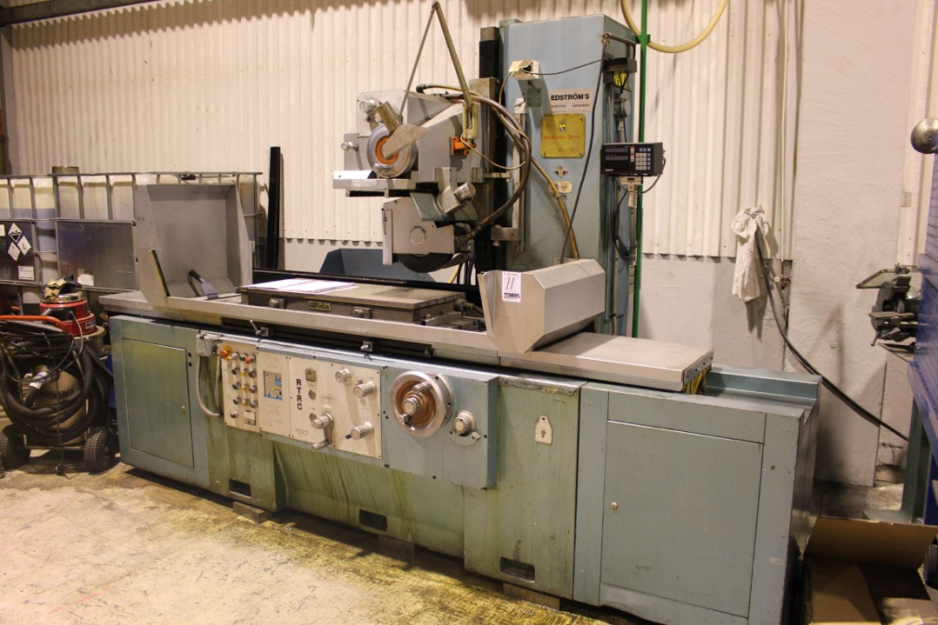
- Distance spindle – table : 600

- Speed range table movement : 0 – 40 M/Min
- Cross feeds per stroke :0 – 20 mm
- Continues cross feeds : 0 – 6 M/Min
- Vertical movement : 0.005

- Wheel : 400 x 127 / 50/60
- Speeds Wheel : 1450 Rpm
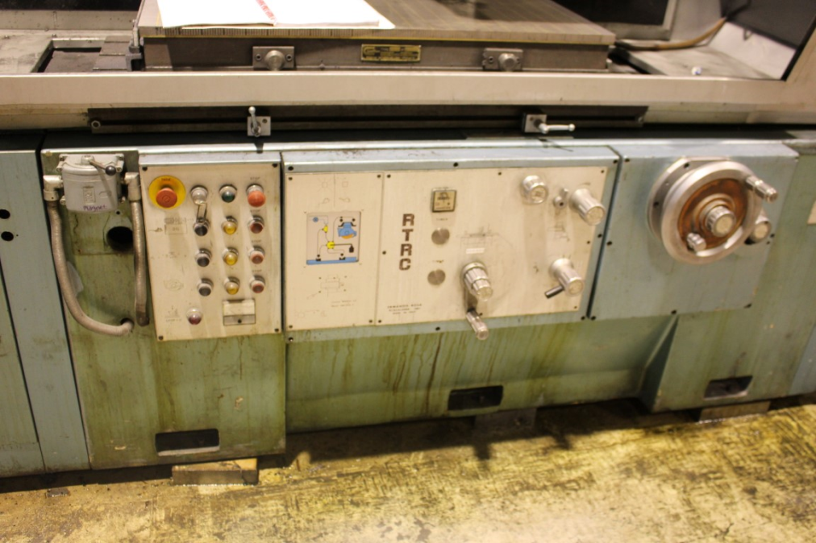
- Dimensions

- Length :
- Width :
- Height :
- Weigth :
- Power :

Please Note: The above information has been obtained to the best of our ability and belief from, and from the manufacturers where possible. It is given in good faith, but its accuracy can not be guaranteed. Accordingly, it will not form a representation or constitute contractual terms. We advise you to check any vital details

